Program Area Focus: Membership

Black Spend Event?  Amount: Enter a decimal amount

Date: **8/30/2021** Location: College Avenue & Foust Park, Greensboro, NC

On **6/19/2021**, the Brothers of the Eta Chapter of Phi Beta Sigma Fraternity Incorporated joined with the Sigmas of the Rho Beta Chapter at UNCG to gather new interests and possible members. Passersby were educated on the core foundations of our wonderous band, and what it means to be a proud member of the organization.

**Goal: To promote the fraternity and gather possible interests.**

|  |  |  |  |
| --- | --- | --- | --- |
| Natl Partner Fundraising Event? | Health Event? | BBB Event? | Education Event? |
|  |  |  |  |

Was there an Outside Speaker/Moderator?

Were funds dispersed?

Disbursement Type: Choose an item.

Funds Recipient: Choose an item.

Amount Dispersed: Enter amount.

The following brothers were involved in the program: *1* brothers participated in this effort. Out of that number, *0* provided materials.

**Total Number of Hours Served: 0 hours**

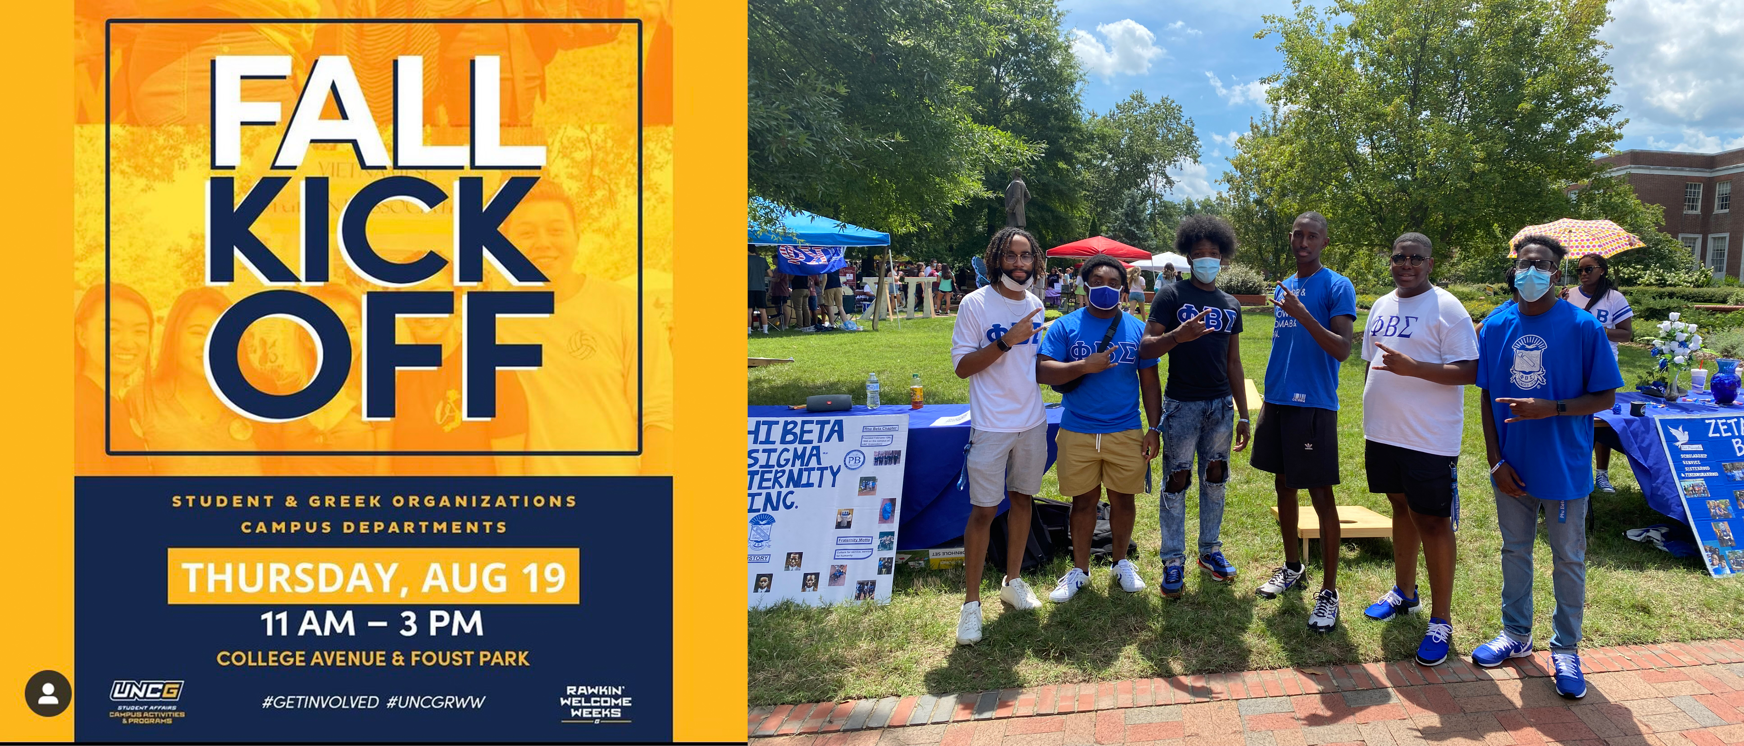

Program Success: **Excellent**

**Recommend this program for the future? Strongly Recommend**